Niall Teague CV
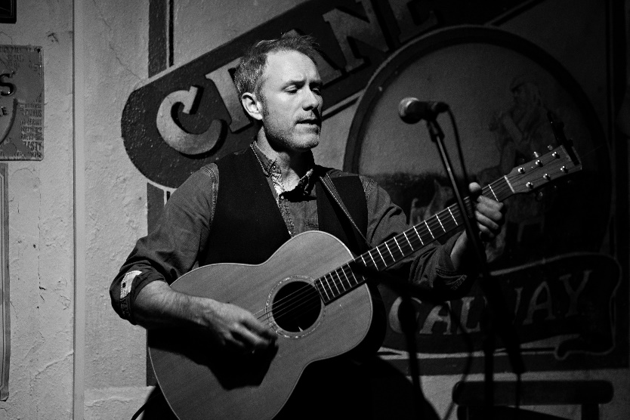
Contact : 3 Saint Dominics Road, The Claddagh, Galway niallteague@gmail.com 0877437737

Professional Profile
Niall Teague is a professional musician, songwriter, performer, producer, and multi-instrumentalist specializing in singing, guitar, and piano with over 20 years’ experience. Niall graduated with a master’s degree in song writing at the Irish World Academy, The University of Limerick in January 2022. Niall has a wealth experience in live performance both in Ireland and UK. Niall has successfully coordinated and funded recording and live performance projects through, self-funding, gofundme, Culture Ireland, Galway City Council and The Department of Tourism, Culture, Arts, Gaeltacht, Sport and Media. Niall has had good results as a collaborator with other musicians and writers in the west of Ireland and recently arranged, produced, and performed on tracks reaching number 2 and 19 in the Irish Download charts (‘Christmas in Dublin’ and ‘West for Christmas’ respectfully). In December 2021 Niall was selected with Padraic Joyce to perform as part of a special streamed event in conjunction with the Black gate Cultural center Galway, showcasing the best in songwriting from Galway and the west of Ireland. Niall has shared the stage with artists such as Sharon Shannon, Shane Mc Gowan, Damian Dempsey, Jack L, Imelda May, Eleanor Shanley and Declan O’Rourke. Niall is also a music educator teaching songwriting workshops to transition year students. Niall is also on the panel of music educators with Music generation Galway. In 2022 Niall was a songwriting coach and teacher for the Transition year students of colaiste na coiribe, Galway. At present Niall is working on a new Album of Folk and acoustic songs due to be released in 2023. Niall is best known as member of Galway’s acoustic trio ‘The Rascals’ and as a performer with ‘4 men and a bass’.

Website: www.niallteagueandpadraicjoycemusic.com
Youtube: https://www.youtube.com/watch?v=0OaALsYvYZY&t=488s&ab_channel=BlackGateGalway
Other bands Groups : The Rascals, 4 men and a bass,

Awards and Honors
2017 – Finalist in Christmas FM Song contest ‘When Christmas comes around
2018 – Galway Advertiser instrumental music recording of the year ‘Uncertain Seas’
2018- Panceltic national song contest winner with ‘Ar Saoire’ collaboration with Padraic Joyce
2018 – Panceltic international song contest winner with ‘Ar Saoire’ collaboration with Padraic Joyce
2019 – Winner of Hard Rock Café Christmas fm song contest ‘Santa Claus’, feat St Nicholas Parochial School Galway
2021 - Oireachtas Irish language song-writing contest winner, ‘Chuile Dhuine lena Scéal Féin’ collaboration with Padraic Joyce
2021 – Finalist in UK songwriting contest with ‘Christmas in Dublin’ collaboration with Deirdre Devally
2022 – Graduated with first class hons ‘Masters of The Arts in Songwriting’ from University of Limerick
2022 – Finalist in Song for Monaghan Contest

Recordings
2009- ‘Witness by Moonlight’ studio album with Breakdown Rambler
2010 – ‘Niall Teague and The Fast Company’ self-released studio album
2018 – ‘Big Red Bridge’ Self released studio album released by Niall Teague and The Fast Company
2020 – ‘Taobh le Taobh’ Studio recorded EP, co-written with Padraic Joyce
2021 – ‘The Ballad of John Delaney’ co – written with Dominic Taylor
2021 - ‘Chuile Dhuine lena Scéal Féin’ co-written with Padraic Joyce
2021 – ‘Christmas in Dublin’ Single co-written with Ma writing student Deirdre Devally
2021 – ‘West for Christmas’ Single co – written with Padraic Joyce
2022 – Monaghan (fairest County in the Land) – written with Padraic Joyce, finalist in Song for Monaghan Contest.

Other Highlights
2009 – Electric picnic performer with Breakdown rambler
2011 – 2012 Piano player in Sharon Shannon band
2012 – Culture Ireland funded touring Artist in The UK with Niall Teague and The Fast Company
2013 –Culture Ireland Funded Artist for UK tour with Niall Teague and The Fast Company
2013 – RTE ‘big music week’ performer, Galway
2021 – ‘Christmas in Dublin’ reaches number 2 in Irish download charts top 100
2021 – ‘West for Christmas’ Reaches number 19 in Irish Download charts top 100
2021 – Support artist to Sharon Shannon
2021 – Support Artist to John Spillane

Other achievements/performances
- Warwick Folk Festival UK
- Purbeck Folk Festival UK
- Bromyard Folk Festival UK
- Temple bar trad fest
- Big Whistle music Festival Bury UK
- Sligo Live
- Galway Fringe festival
- BBC Radio Lancashire live performance
- RTE Radio live performances

