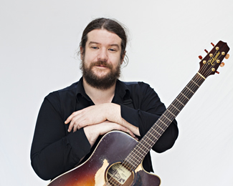
PADRAIC JOYCE
Padraic hails from Rossaveal in Connemara and has been playing guitar, singing and composing songs since his teens, when as a member of the band Minera, he was a winner of the national songwriting competition, “An Comórtas Amhrán NuaChumtha”, in 1997 and went on to represent Ireland in the International Pan Celtic Song Contest that same year.
Whilst studying at NUIG, he was a member of the band Breakdown Rambler, appearing on the TG4 shows Ardán and Síbín. Their music featured in the multi award- winning short film El Toro, which is now part of the Leaving Certificate Gaeilge syllabus.
After completing his degree at NUIG, Pádraic studied Traditional Music production and composition under Charlie Lennon at NUIG and spent a year in the Access Music Project as well as studying Music Theory and Composition at GCC.
In 2018, Pádraic returned to An Comórtas Amhrán NuaChumtha; winning the contest with the song Ar Saoire, which he co-composed with Niall Teague. They went onto represent Ireland at the International Pan Celtic Song Contest and won that competition as well. The track Ar Saoire is scheduled to feature on the album they are currently working on. In 2020, they won 4FM’s Christmas Song competition and were the winners of Oireachtas na Gaeilge’s inaugural song-writing contest last year. Their most recent single, “West For Christmas” cracked the Irish Top 20 Download Charts
Pádraic is also a member of Tracy Bruen’s band. Tracy is a well-known Galway based singer songwriter. Pádraic played lead guitar on her recent single Dream Away which reached Number 2 on the RTÉ Radio One Request Chart earlier this year.
As a band, they have recently supported The Stunning at Pearse Stadium and are currently working on an album, which will feature the song, “Better Than This”, which received widespread national airplay last year.

